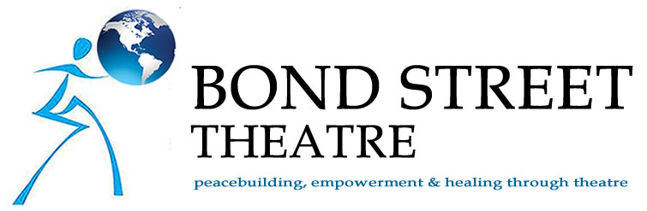
2 Bond Street,
New York, NY 10012
212-254-4614
www.bondst.org
info@bondst.org

BOARD MEETING MINUTES
Monday, September 21, 2015

TIME – 6:00-8:00 pm

LOCATION – Frank Juliano’s Apartment
33 West 75th Street, 3A

Members present:
Frank Juliano, President
Joanna Sherman, Vice President
Ethel Barber
Alice Leopold
Mary Dino (via Skype)
Ruth Wikler-Luker (via phone)
Scott Kamen (via phone)

Members absent:
Patrick Sciarratta

Staff present:
Michael McGuigan, Managing Director – recording Minutes

Handouts:
- Meeting Agenda
- Current Grants List
- Results of Board Skills and Committee Interests sheets

CALL TO ORDER…………………………………………………………..…….6:20 pm

Minutes of June 12, 2015 meeting approved.

Review actionable items from last Board meeting
- All members to send Joanna filled-in Skills and Committee Interest sheet. – Done.
- Office to create ToR for Executive Director. — Not yet completed.
- Scott to connect Joanna with potential ED candidate, Brittany. – Done.
- Ethel to connect Joanna with potential ED candidate, Lynn Winters.—Done.
- Joanna and Frank to meet with two PR firms. –- Not yet completed.
- Office staff to update Trustee Portal with recent handouts. – Done.
- Ethel to check in with her current CPA who’s retiring soon. – Done (see follow-up)

1. DISCUSSION TOPIC: Scott’s Salon
- Scott wants to throw a fundraising “Bash” at his home and nearby park overlooking Hudson, with entertainment and something demonstrative of BST’s work.
- Scott will use same guest list from last event, plus additions from BST and Board.
- Date is set for Sunday, November 1st. [Note: later updated to Sunday, November 15th]
- Frank suggests the Hudson Writers Lab as an alternative space.
- Joanna recommends that Scott head up the Fundraising Committee for the event.

2. DISCUSSION TOPIC: Structuring and Advancing the Board (cont’d)
- Ruth announces that she is leaving the Board at year end due to her distance. Mary also announces intentions to leave the Board due to her schedule. Patrick will also be stepping off the Board. Joanna suggests that members space out their departures as new members join.
- Discussion regarding a Governance committee to review topics such as: by-laws (outlining board terms, roles, committees, etc.) and non-profit requirement to register in every state. Members: Ruth, Frank, Mary.
- Alice suggests addition of a board assessment procedure; for example, the American Heart Association has bi-annual board report cards.
- Discussion of potential new Board members. Everyone to be on Board Selection committee.
- Alice says we need greater visibility in NYC. Board members must go to local events and network. A Syrian refugee project would make a big difference. Afghanistan is old news. Fundraising/Networking Committee: Scott, Ethel, Alice.
- Frank suggests the idea of partnering with some other organization with a sympathetic mission; for example: Religions for Peace, Wounded Warriors, etc.
- Suggestion to create an “honor society” of our consistent donors over 10 years. Perhaps honor them at the upcoming fundraising event.

ACTIONABLE ITEMS:
- Office to send out list of committees created.
- Scott to talk to Syd, Ethel’s CPA connection.
- Office to upload current by-laws to Trustee Portal.
- Joanna to send logo jpg to Frank and Alice for a Logo Pin.
- Joanna and office to create 10-year donor “honor roll”.
- Ethel to look into Susan Perlstein’s guest list for event.

ADJOURN……………………………………………………………….………..8:00 pm

